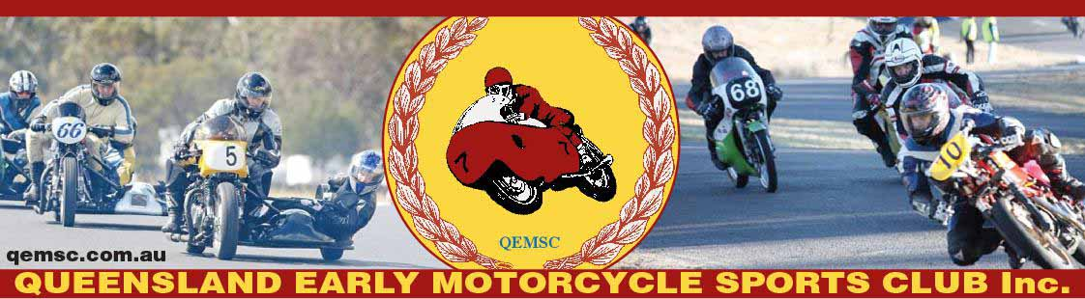
QEMSC
PO Box 3188
Southport BC
QEMSC Members results at the AHRRC at Lakeside on 25th – 28th September 2014.
P2 Senior
Terry Kavney 2nd
Guy Vickerman 3rd
Ian Milton 4th
P3 Lightweight 250
Graeme Osborne 3rd
Fred Van Loenen 7th
P3 Junior 350
Peter Morrow 5th
Colin Meredith 6th
Bruce Marston 7th
Ross Hollands 9th
Gary Slater 12th
Paul Chesher 13th
P3 Senior 500
Tony Glazebrook 6th
Bruce Marston 8th
Doug Aitchison 14th
Mark Jones 15th
Bob Blythe 16th
Bruce Russell 18th
P3 Formula 700
Tony Glazebrook 2nd
Rod Torr 6th
P3 Unlimited
David Woolsey 1st
Tony Glazebrook 3rd
John Munns 6th
Greg Brillus 11th
Rod Torr 18th
Jon Wadling 19th
Bruce Russell 20th
P3 Sidecars
Bruce/Graham Marston 1st
Tony Jacobs/Nathan May 3rd
Mick/Dylan Moore 4th
James McKenzie/Dylan Deane 5th
Ian Milton/Vicki Butler 12th
Lex Dreier/David Vincent 16th
Matt klein/Rod Torr 17th
P4 ULW 125
John Eastwood 1st
Brian McGrath 2nd
P4 LW 250
Don Radke 3rd
Graeme Osborne 6th
Steven Daw 7th
Dave Keenan 10th
Wayne Carey 11th
Terry Kavney 12th
P4 Junior 350
Ben Endicott-Davies 5th
Dave Keenan 9th
Matt Wade 10th
P4 Senior 500
David Woolsey 3rd
Damian Kavney 4th
Tony Sovar 6th
Dave Kavney 9th
Mark Jones 10th
Geoff Martin 11th
P4 Formula 750
Darin Aitchison 5th
P4 U/L
John Downs 4th
Mark Faulkner 5th
Owen Ward 6th
Darren Tindale 7th
Brian Greaves 8th
Cam Huxley 9th
P4 Sidecars
Lindsay Donai/Christine Menzies 1st
John Wormald/Darryl Skewes 3rd
Damian/Robert Deane 6th
Emma/Peter Waring-Jones 7th
P5 ULW125
Bernie summers 2nd
Steve Gordon 3rd
Darren Tindale 5th
Jason Tester 7th
James Barclay 10th
P5 LW 250
Bernie Summers 8th
Ant Sykes 11th
P5 Junior 350
Brett Chandler 16th
Graeme Osborne 22nd
Brian McGrath 24th
P5 Senior 500
Brad Phelan 4th
Bob Garner 5th
Mick Bryan 8th
Bill Ross 11th
David Tye 12th
David Hannah 13th
P5 Formula 750
Bob Garner 4th
Brad Phelan 5th
Mick Bryan 6th
Tony Sovar 8th
Guy Vickerman 10th
David Hannah 11th
P5 U/L
Damian Kavney 5th
Bob Garner 17th
P5 sidecars
P6 ULW 125
Mark Strong 5th
James Barclay 7th
Jason Tester 8th
Terry Kavney 9th
P6 250 Production
Ray Clacher 7th
Graham Lawrence 11th
John Misiuda 12th
P6 LW 250
Ray Clacher 8th
Stuart Brown 9th
P6 Senior 500
Ray Clacher 14th
Paul Chesher 15th
John Eastwood 16th
Glen Hewitt 17th
Gerard Purcell 18th
Peter Herlihen 19th
John Gordon 21st
Martin Fagg 22nd
P6 Formula 750
John Eastwood 8th
Simon Trott 9th
P6 Formula 1300
Steve Harriman 15th

